**Setup Documentation Outline**

**Introduction**

**Purpose of the Setup**: This documentation aims to guide users through setting up a development environment for software engineering projects, encompassing essential tools and configurations. **Tools and Technologies Used**: Windows 11, Visual Studio Code, Git, GitHub, Python, MySQL, Docker.

**Operating System Installation**

**Step-by-Step Instructions**:

1. Download Windows 11 from the official website.
2. Create a bootable USB drive using Rufus.
   1. Launch Rufus: Run the Rufus software on your computer.

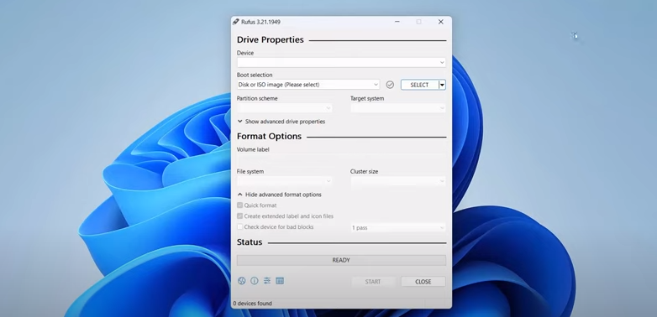

* 1. Select the USB Drive: Choose the USB flash drive you want to use from the drop-down menu.

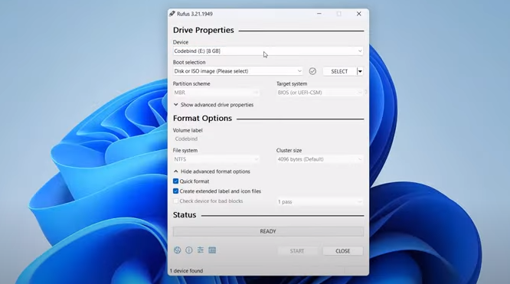

* 1. Select the ISO Image: Click on the “Select” button next to “Create a bootable disk using” and select the ISO image file you downloaded.

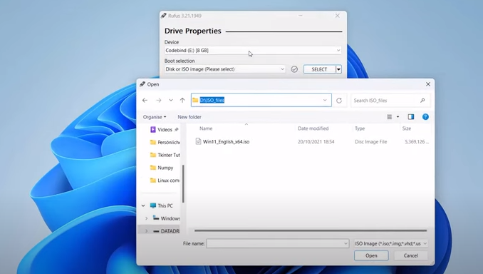

* 1. Set the Boot Selection: Ensure the “Boot Selection” option is set to “Disk or ISO image” and select the correct USB drive.
  2. Start the Process: Click the “Start” button to begin the process.

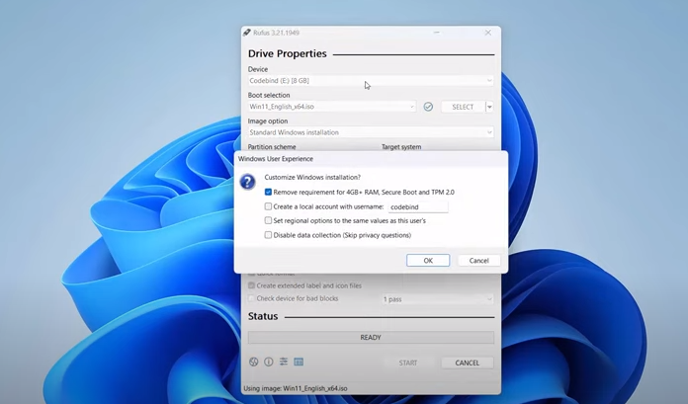

* 1. Wait for the Process to Complete: Rufus will create a bootable USB drive from the ISO image. This process may take a few minutes.

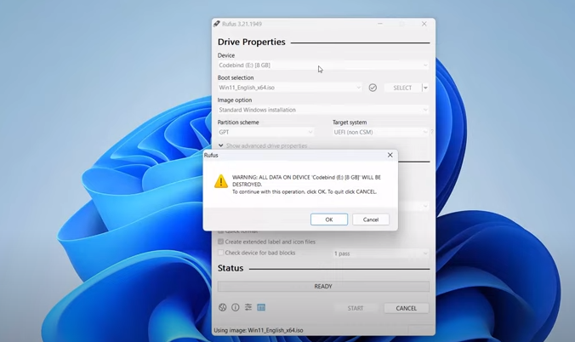

* 1. Verify the Bootable USB Drive: Once the process is complete, verify that the USB drive is bootable by inserting it into another computer and restarting it.

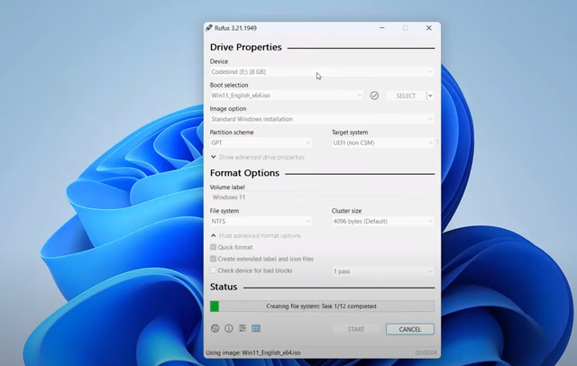

1. Boot from the USB drive and follow on-screen instructions for installation.

**Text Editor/IDE Installation**

**Instructions for Visual Studio Code**:

1. Download Visual Studio Code from the official website.

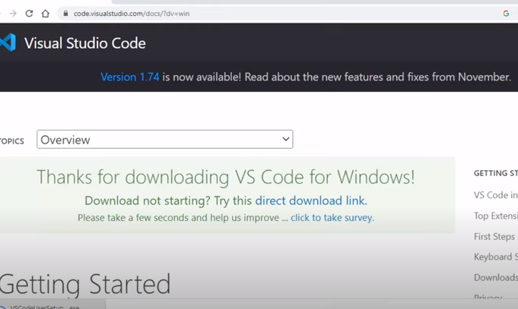

1. Run the installer and follow the installation wizard.

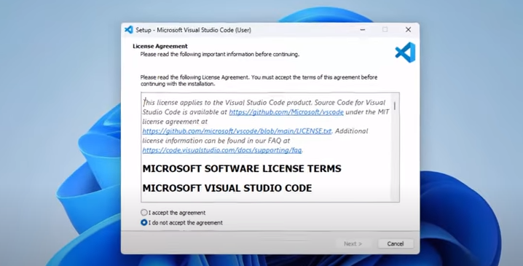

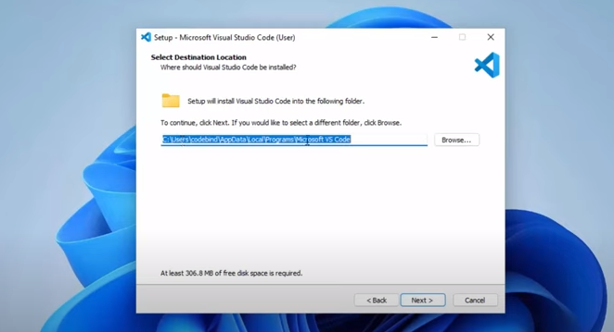

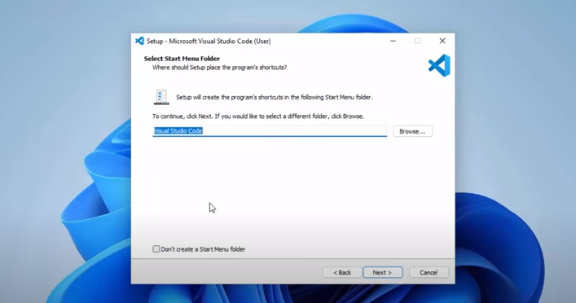

**Version Control System Setup**

**Git Installation Steps**:

1. Download Git from the official website.
2. Run the installer and follow the installation wizard. 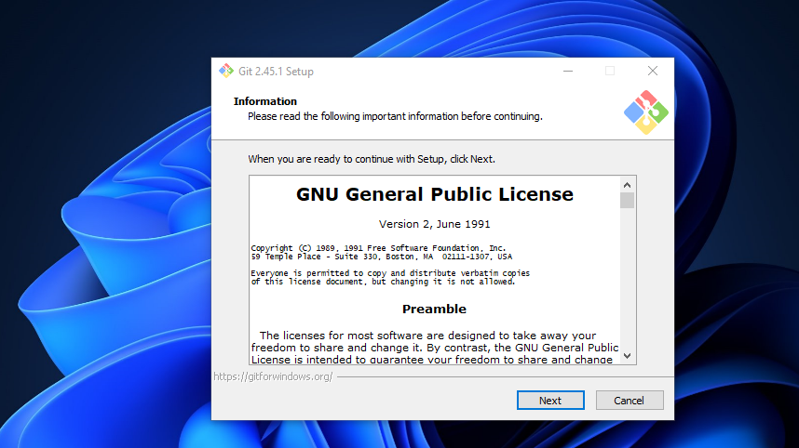

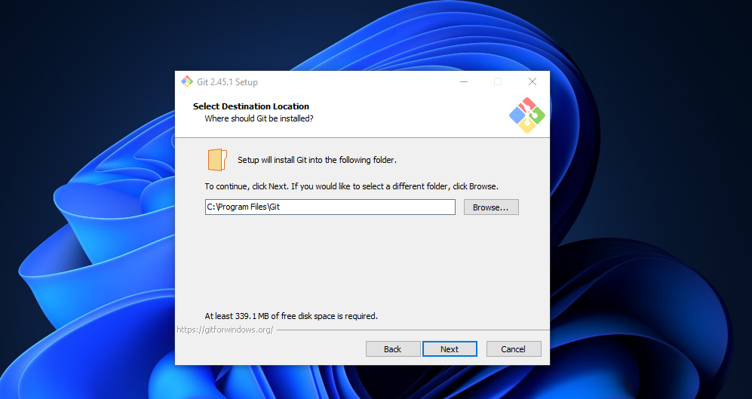

**Programming Language and Runtime Installation**

**Installing Python**:

1. Download Python from python.org.
2. Run the installer and select "Add Python to PATH" during installation. **Verifying Installation and Setting Up pip**:
3. Open a command prompt and run **python --version** to verify the installation.
4. Run **pip --version** to check if pip is installed. **Screenshots**: [Include screenshots of verifying Python installation].

**Database Configuration**

**Steps for MySQL**:

1. Download MySQL from the official website.
2. Run the installer and follow the installation wizard.

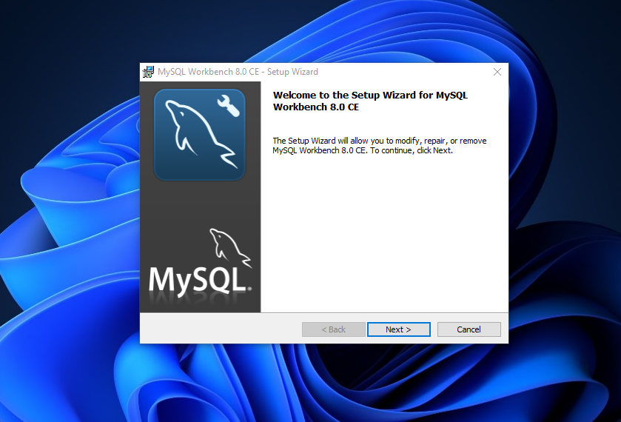

1. Configure MySQL with desired settings.

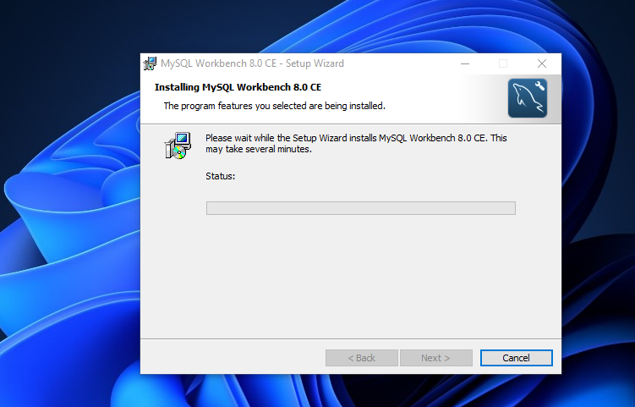

**Conclusion**

This documentation has provided step-by-step instructions for setting up a development environment, covering essential tools and configurations. Establishing a robust development environment is crucial for smooth project development and collaboration.